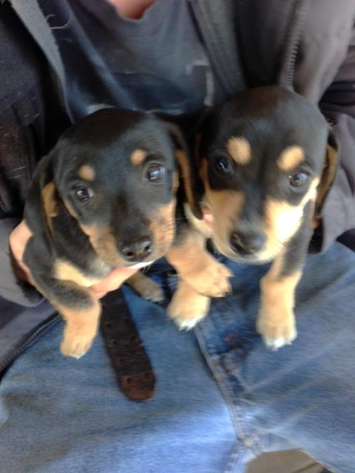These two little Dachshund puppies were brought to us one day by someone in Nixon who could not keep them. With the cooperation of Dachshund Rescue of Houston, this duo now has forever homes. We would like to Thank Dachshund Rescue of Houston for helping us find homes for the majority of our Dachshunds.

