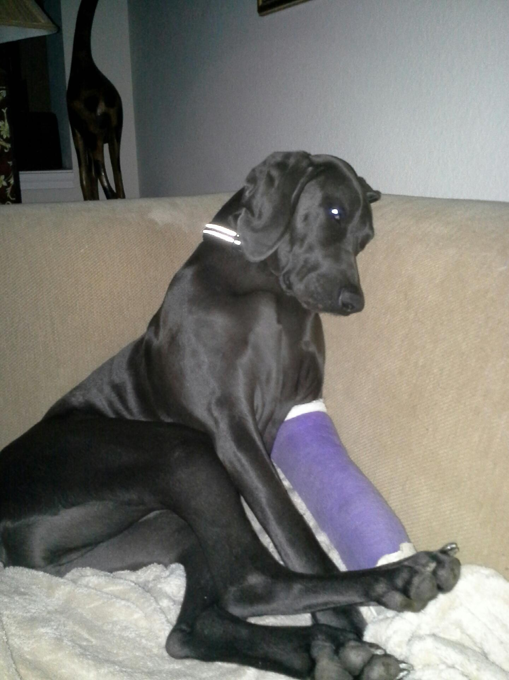

This is Sam, an eighteen-month old purebred Weimaraner. On January 27, 2014, Etosha Rescue was contacted by VCA Health Associates Animal Hospital in San Antonio with a sad story about this dog. He was left at the animal hospital by his owner and scheduled for euthanasia at six p.m. because he had a broken leg. Hospital personnel contacted several well-known rescue organizations in San Antonio, but none were interested in helping Sam. In a last ditch effort to save his life, VCA contacted Etosha, which sent a volunteer within the hour to pick him up. Sam’s broken bones were set the next morning by our vet and a plea for donations to cover the bill went out the same afternoon. Weimaraner Rescue of Texas stepped up to take Sam into their program a few days later, and we hear he’s doing well in a foster home. His story is a familiar one to all of us at Etosha, but it’s one that could have ended a lot differently. Unfortunately, a day will come in the not too distant future when we won’t be able to help dogs like Sam from Bexar County due to lack of funding from San Antonio foundations.

